Contract Manager
Introduction
– Contract Manager;
1.Gopika . K.
2.Mathivadhani.T.
3.Monica.K.
4.Abarna Balaji.R.

Project Execution;
Execution Steps:
- Open the project folder in the terminal.
- Make sure you have a start script in the package.js file.
- Use the command npm start to start the server.
- You will the Running on PORT message on the successfully starting the server.
- You will also see the database connected message if the database is connected successfully.
- Use the Thunder client or Postman for using the created api’s .

Output Screenshots;

1.Register Api;

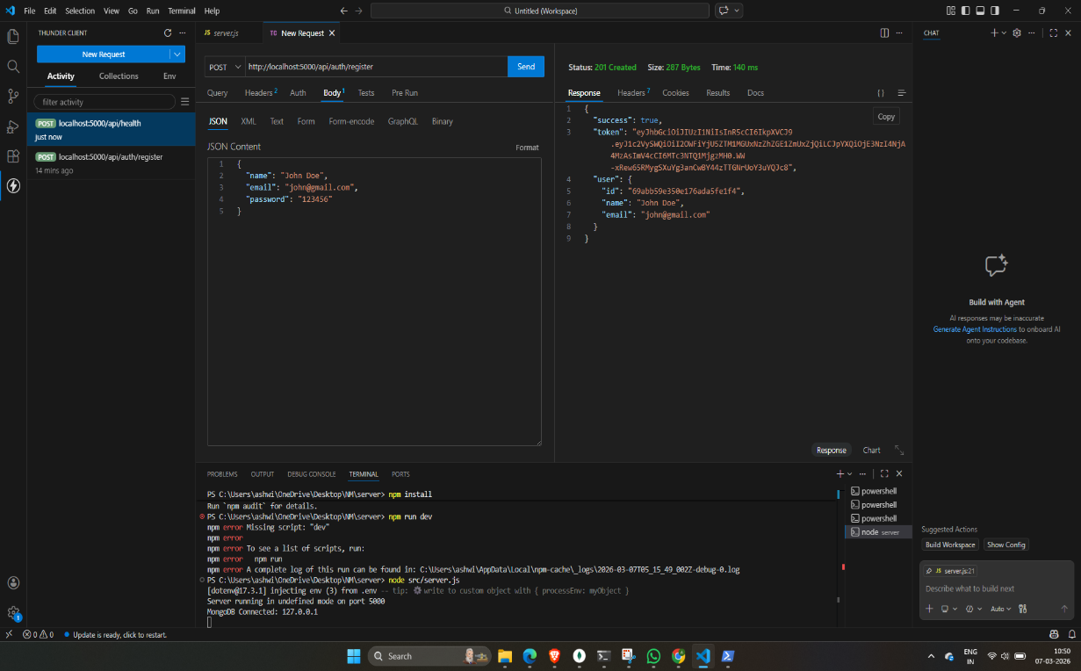
2.Login Api;
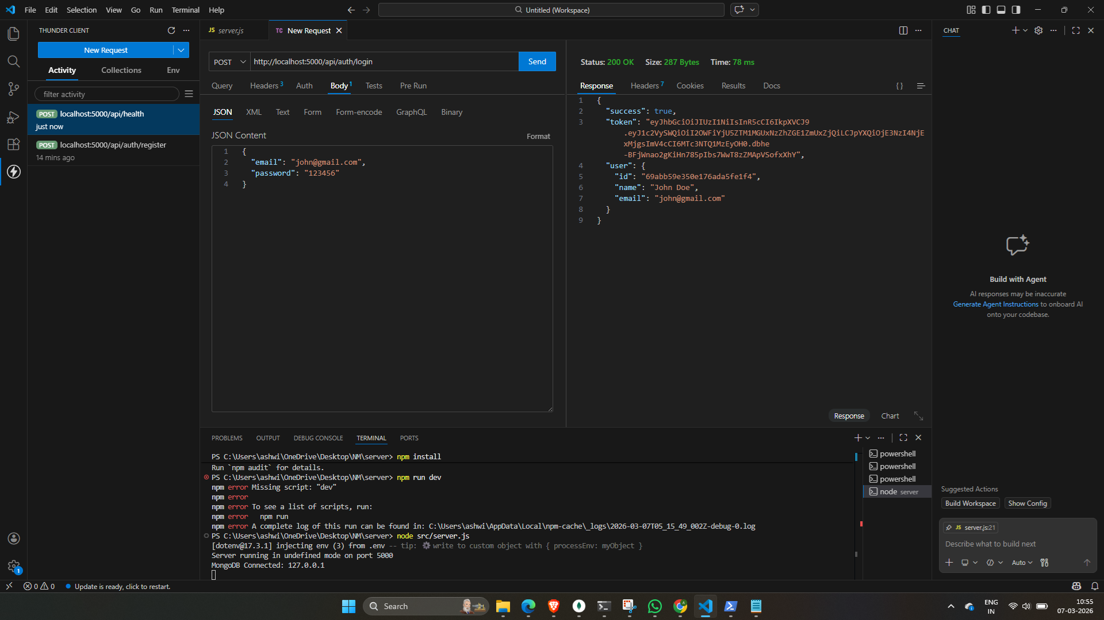
3.Create New Contact;
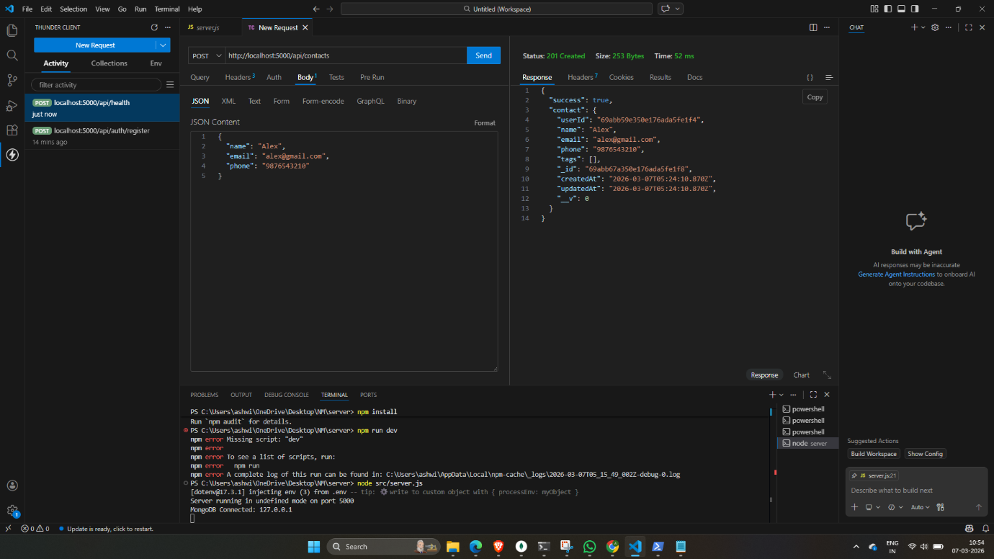
4. Update Contact;
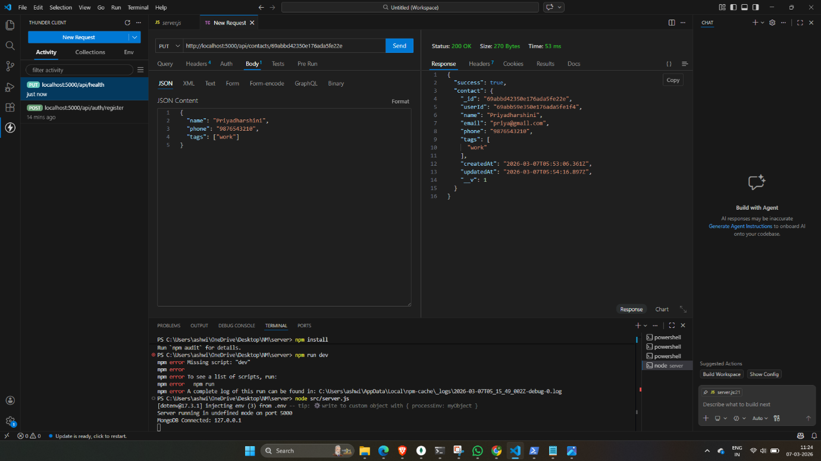

5. Delete Contact;
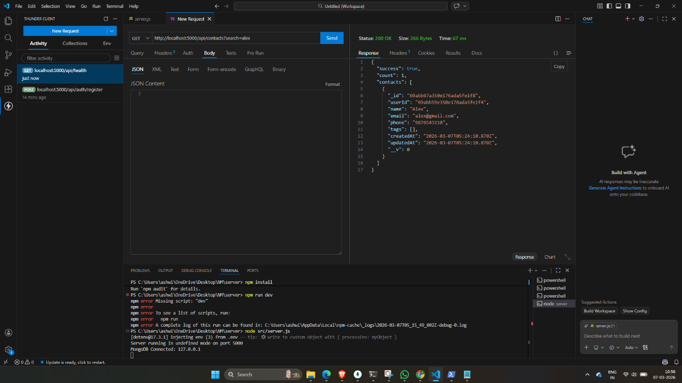
6. Search Contact;
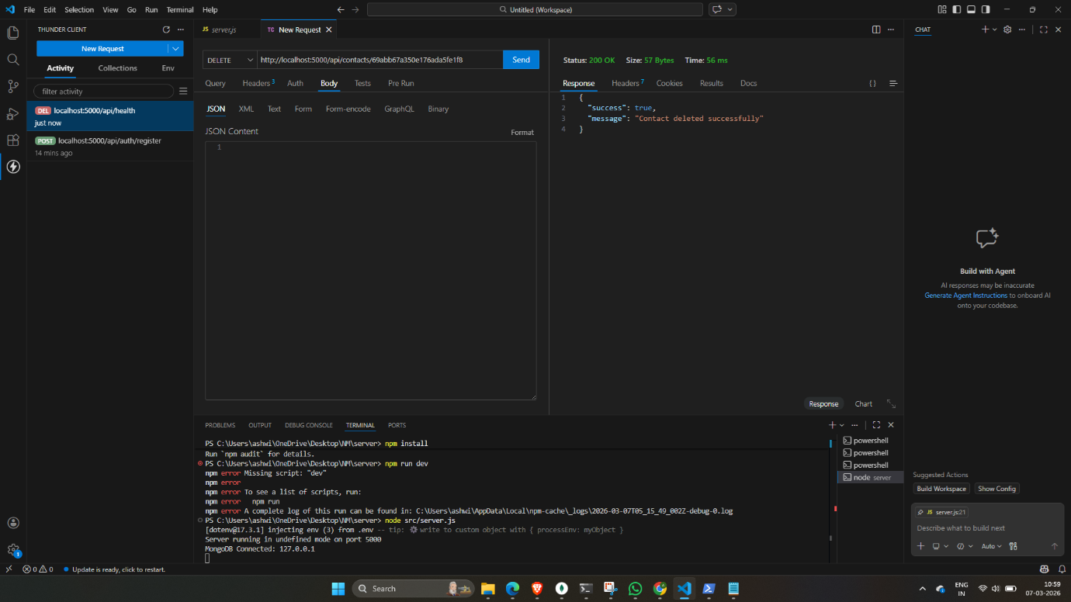

7.Get The Current User;
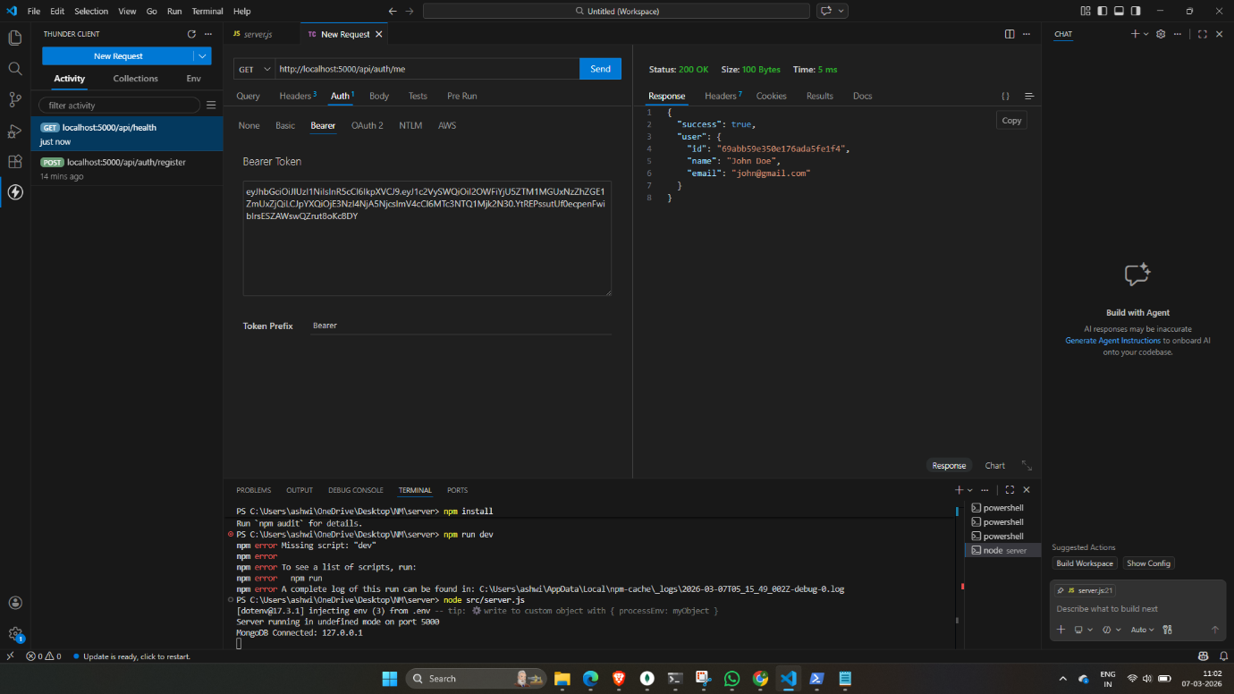
Conclusion;
In conclusion, a Contract Manager is responsible for managing and checking contracts in an organization. They make sure that all agreements are followed correctly and that the work is completed on time. This role helps the organization run smoothly and ensures that everything is done according to the agreed terms.

